



Instructor:

**[It Expert](https://www.youtube.com/watch?v=yGU4YfSSjdM&t=6s&ab_channel=ITExpert)**

Youtube

Owner:

[**Azamat**](https://t.me/Azamat_Nishonov)[**Nishonov**](https://t.me/sql_portfolio_24)

SQL Developer

Content

Data types 3

Create table 3

INSERT STATEMENT 4

TRUNCATE Table va DROP Table 4

CROSS JOIN 6

FUNCTIONS 8

STRING FUNCTIONS 8

Numeric function 10

Convertion Function 10

Sequence (auto_increment) 12

Pseudo Columns 13

Data Dictionary 14

Notepad file 14

View 15

Input Variable 16

Define variable 18

PL/SQL 18

PL/SQL Procedure 18

# Data types

|  |  |
| --- | --- |
| INT | Whole numbers |
| DECIMAL(M,N) | Decimal Numbers - Exact Value |
| VARCHAR(length) | String of Text Lenght |
| BLOB | Binary Large Object, Store Large Date |
| DATE | User for Date'YYYY-MM-DD' |
| TIMESTAMP | 'YYYY-MM-DD HH:MM:SS' use fro Recording |

# Create table

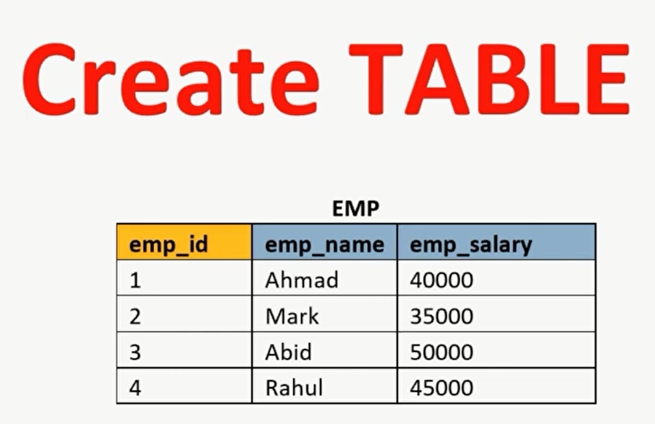

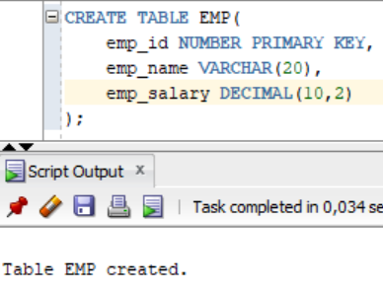 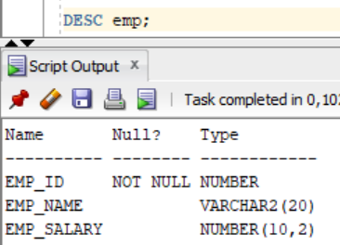

# INSERT STATEMENT

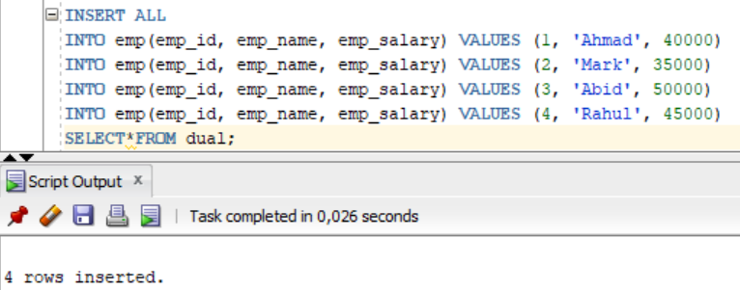

# TRUNCATE Table va DROP Table

TRUNCATE TABLE da WHERE bandi bo’lmaydi.

TRUNCATE TABLE ishlatilsa, ma’lumot o’chadi, lekin sxema qoladi.

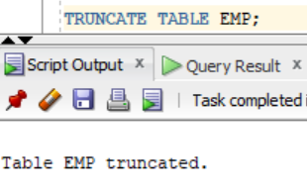 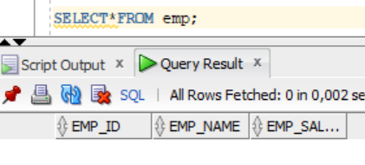

DROP TABLE sxemani o’chiradi.

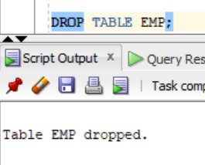 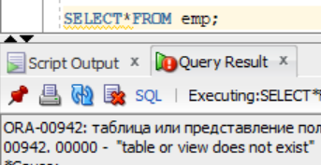

Department jadvali

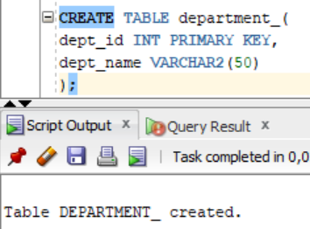

Emp jadvaliga ustun qo’shamiz:

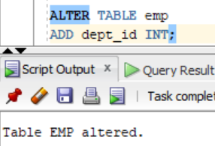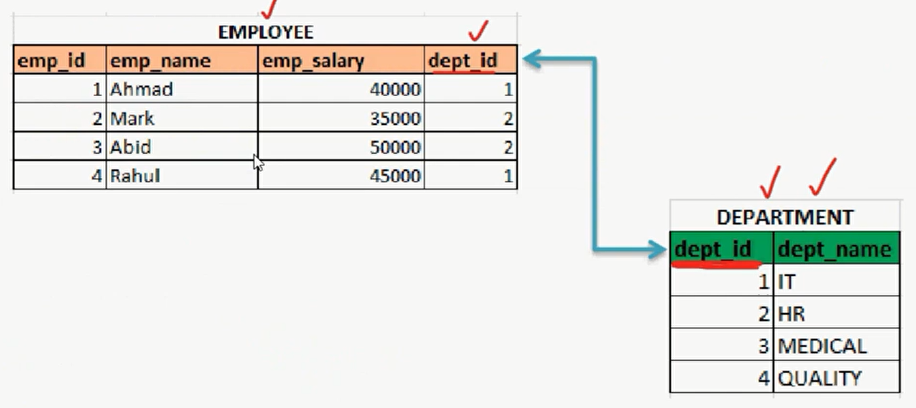

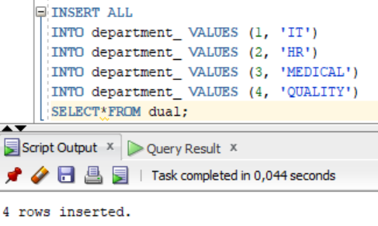

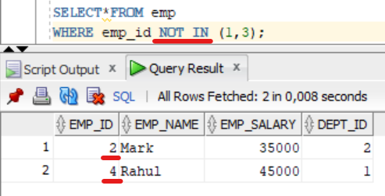

# CROSS JOIN

CROSS JOIN — 1-jadval qatorlarini, 2-jadval qatorlariga ko’paytiradi.

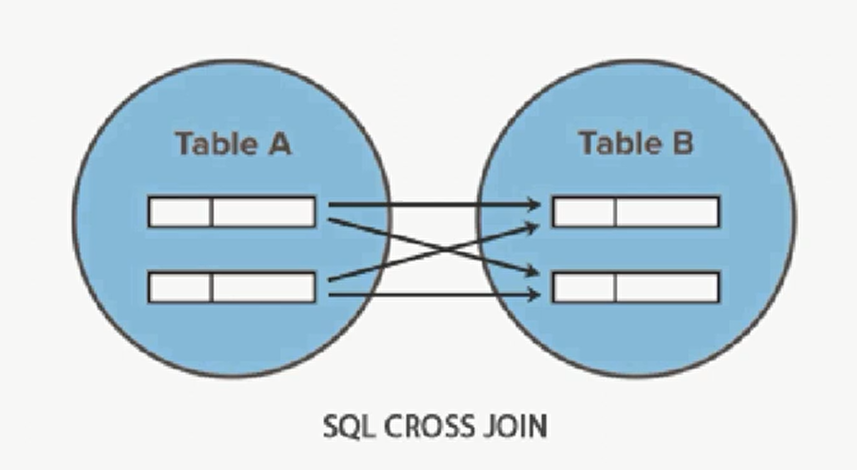

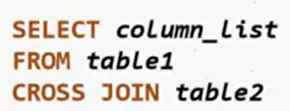

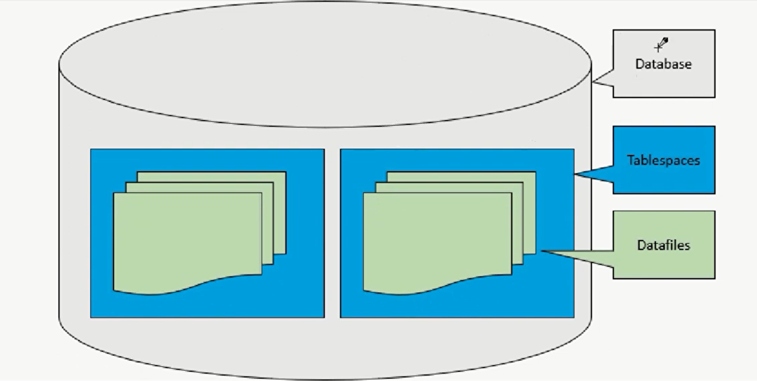

User jadval maydoni:

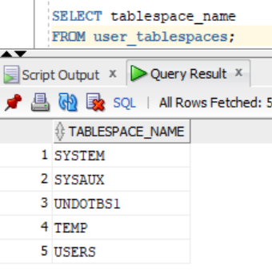 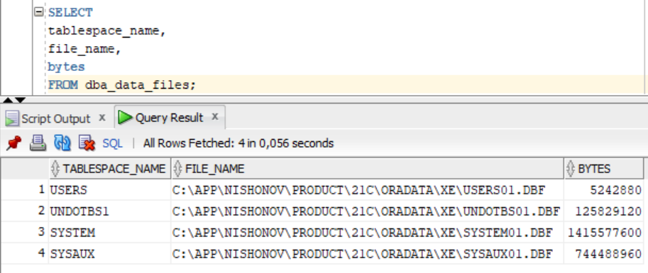

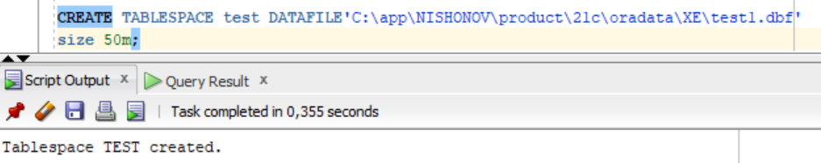

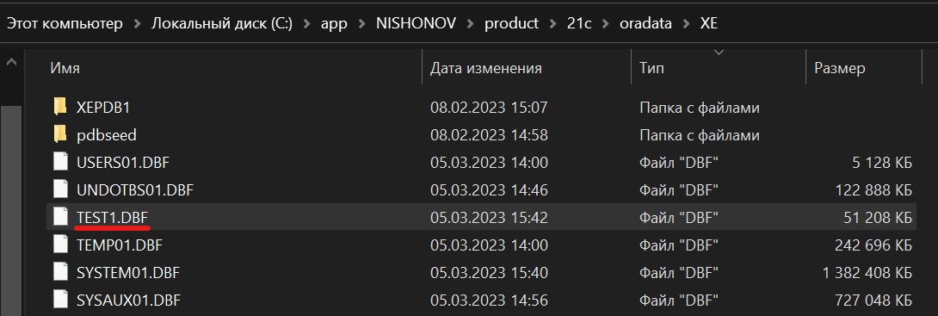

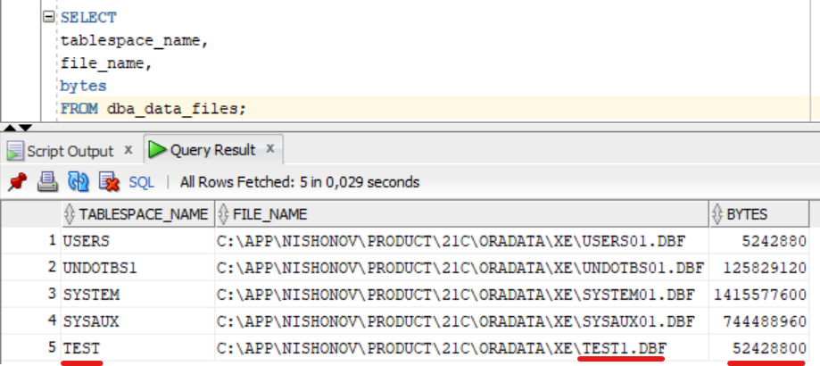

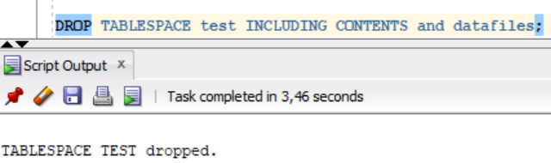

# FUNCTIONS

## STRING FUNCTIONS

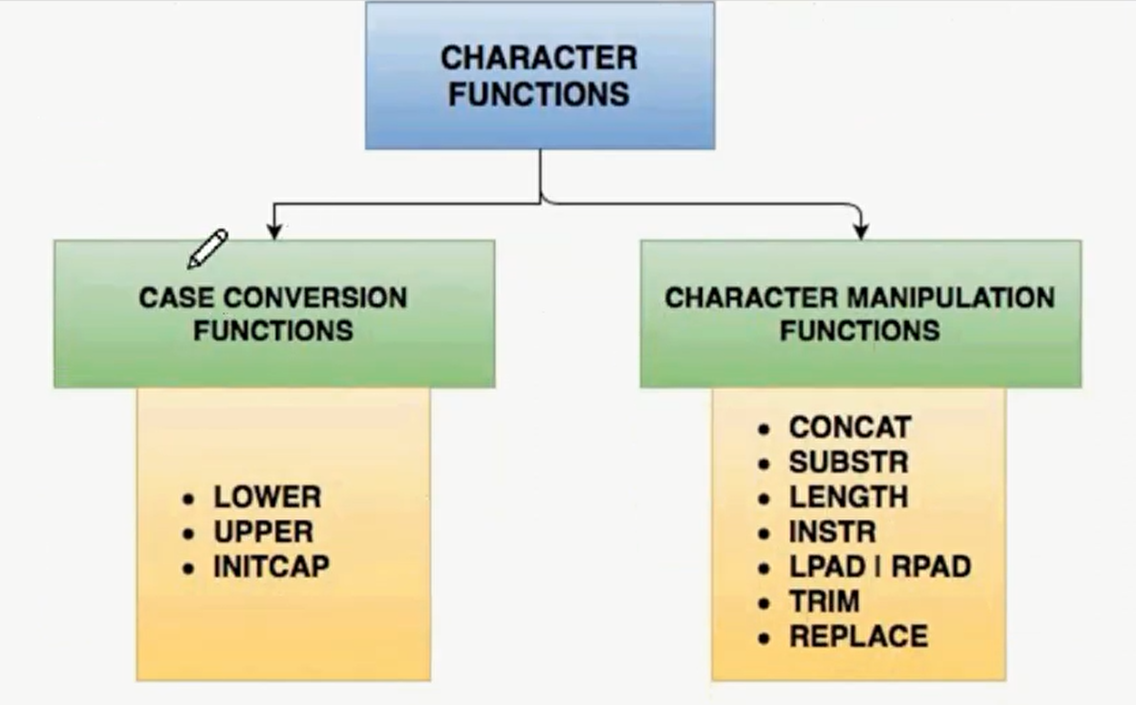

LOWER(...) — barchasi kichik harflar

UPPER(...) — barchasi katta harflar

INITCAP(...) — har bir so’z katta harf bilan boshlanadi

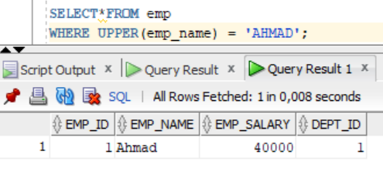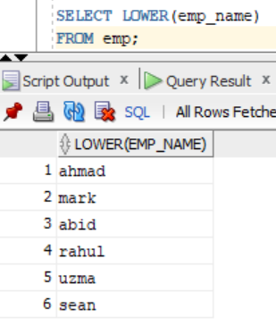

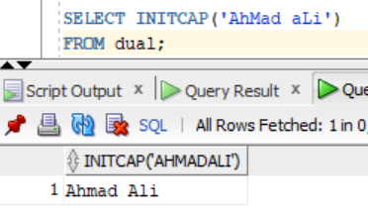

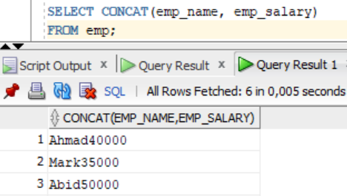 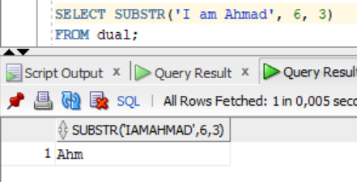

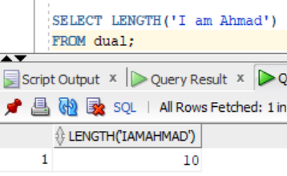 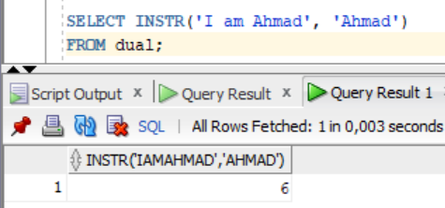

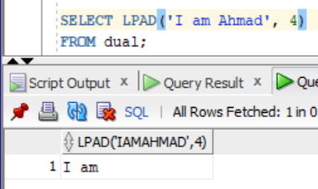 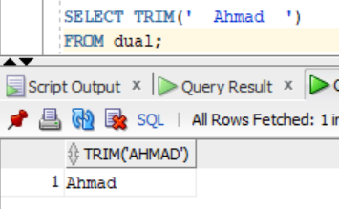

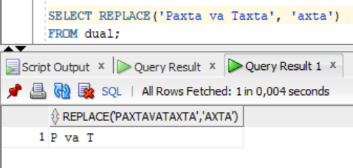

REVERCE 🡺 Harflarni teskari tartibda chiqaradi:

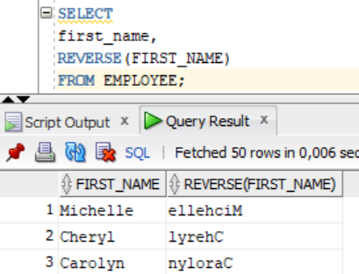

## Numeric function

CEIL(n) => CEIL(10.3) = 11

FLOOR(n) => FLOOR(10.7) = 10

ROUND(n,m) => ROUND(10.45795, 3) = 10.458

POWER(n,m) => nm => POWER(5, 3) = 125

MOD(n,m) => n/m ning qoldig’i => MOD(9,5) = 4

SQRT(n) => ildiz

ABS(n) => modul => ABS(-10) = 10

TRUNC(n,m) => TRUNC(29.16, 1) = 29.1

TRUNC(38.2,-1) = 30

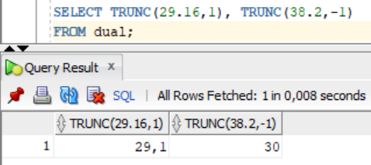

## Convertion Function

TO_CHAR => belgilarga aylantiradi

TO_DATE => sanalarga aylantiradi

NVL => Bo’sh qiymatlarni qiymatli qilib chiqaradi.

DECODE => qisqartmalarni yoyish uchun ishlatiladi.

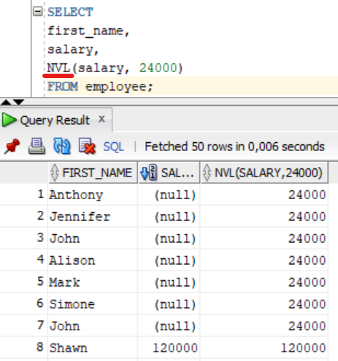

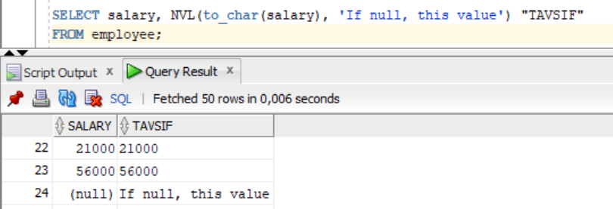

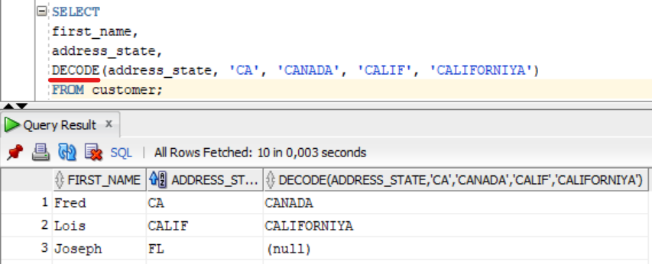

# Sequence (auto_increment)

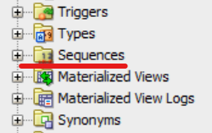

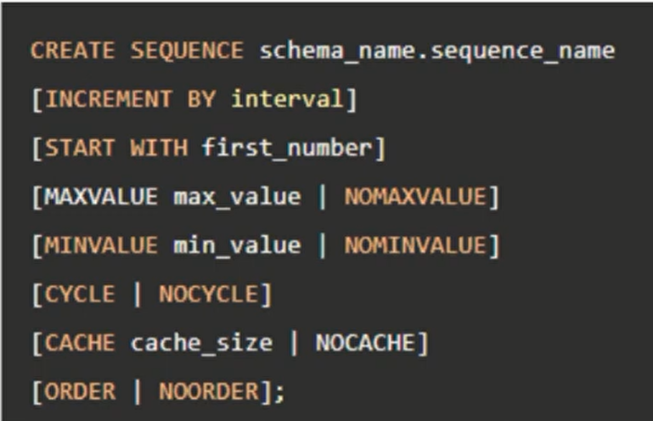

Create Sequence:

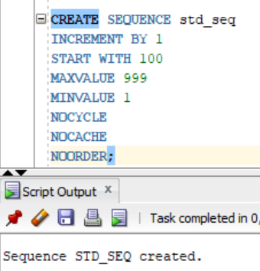

Insert into:

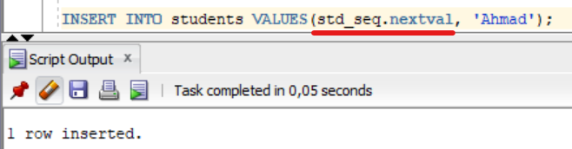

Hozirgi vaqtdagi so’nggi qiymatni aniqlash:

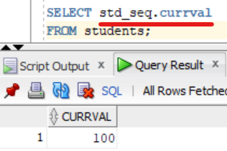

Tekshiramiz:

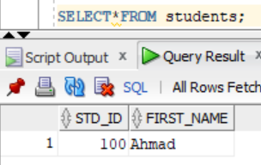

# Pseudo Columns

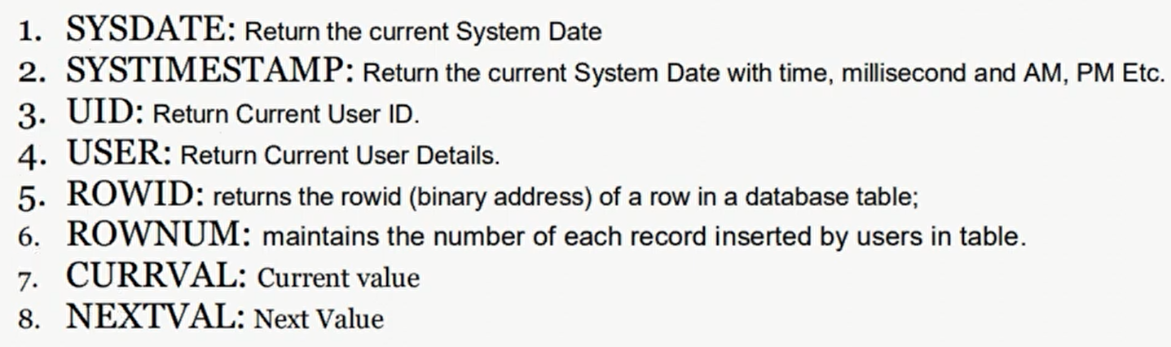

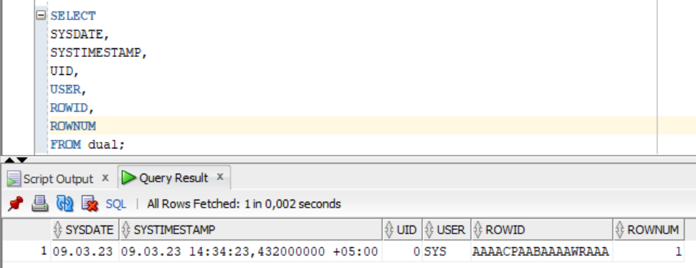

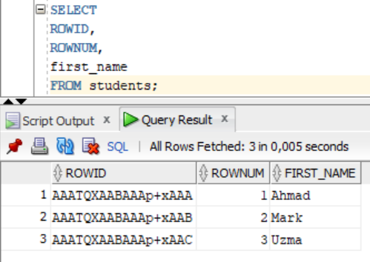 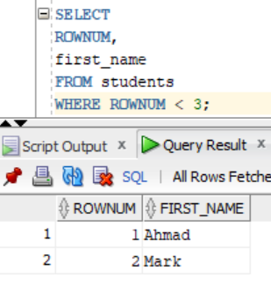

# Data Dictionary

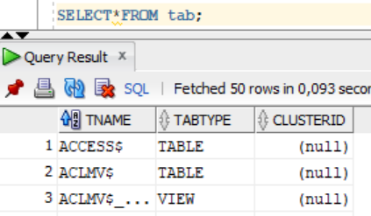 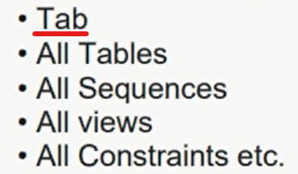

## Notepad file

Bloknotga kerakli so’rovni yozamiz:

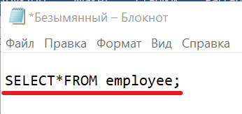

Sql tipda saqlaymiz:

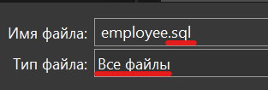

Sql developerda ***START*** bilan faylni chaqiramiz:

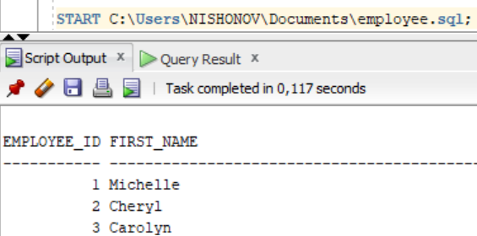

# View

*View*ni yaratish:

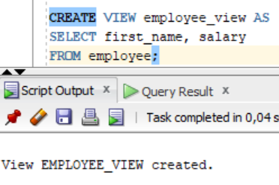

*View*ni ko’rish:

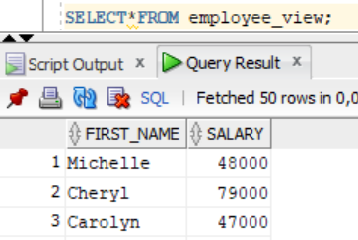

*View*ni o’zgartirish:

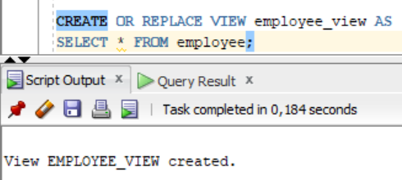

O’zgartirilgan *view*ni ko’rish:

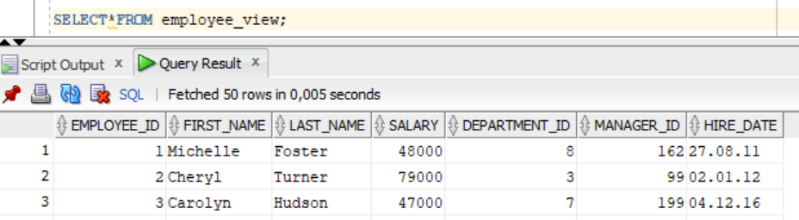

*View*ga Insert qilamiz:

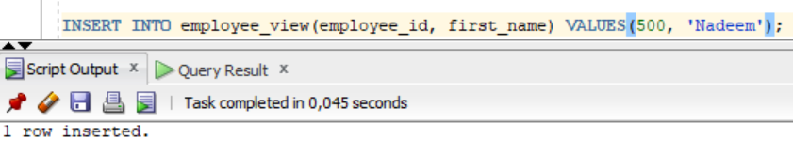

Kiritilgan ma’lumot jadvalga qo’shildi.

*View*ni o’chirish:

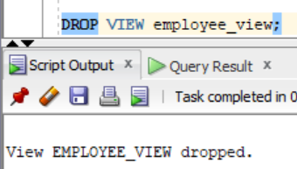

# Input Variable

Qiymat kiritib javob olish:

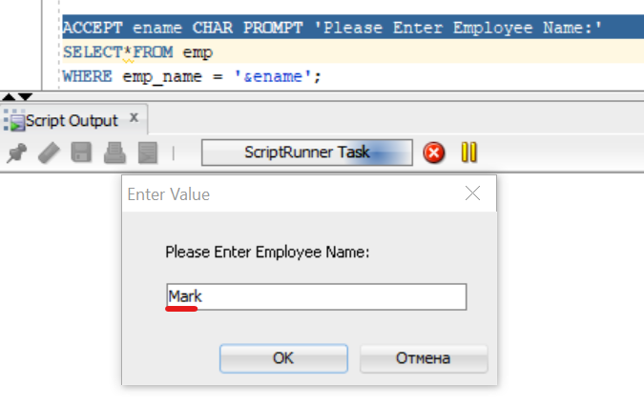

Javob:

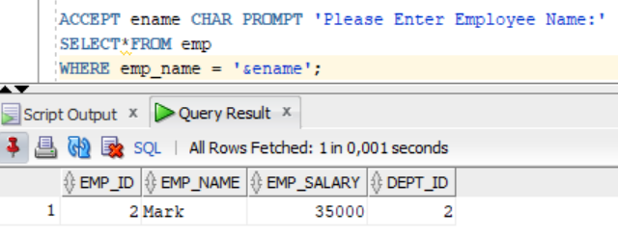

2-variant. Nomer kiritiladi:

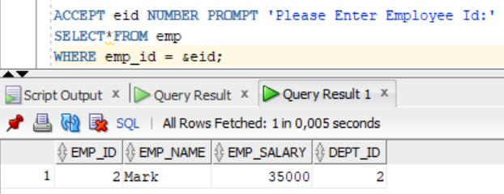

## Define variable

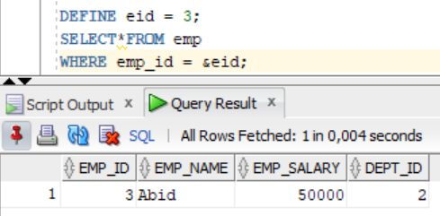

# PL/SQL

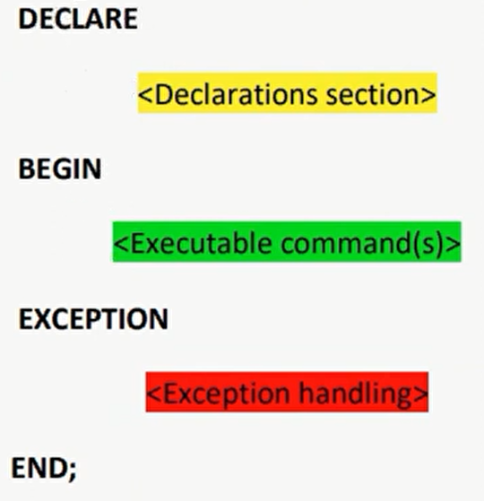

# PL/SQL Procedure

Syntax:

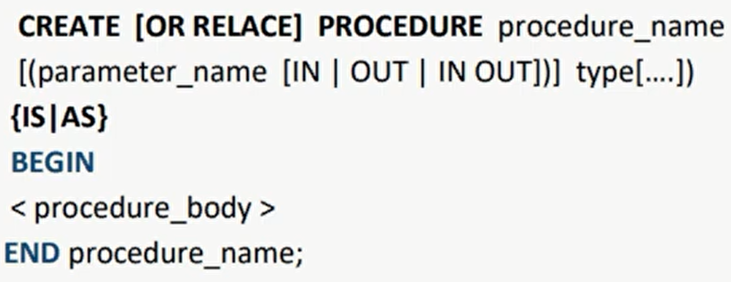

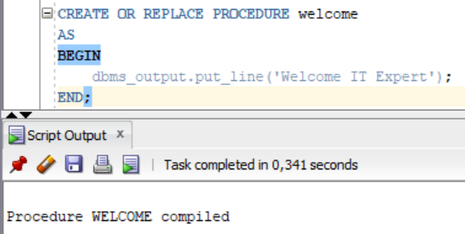

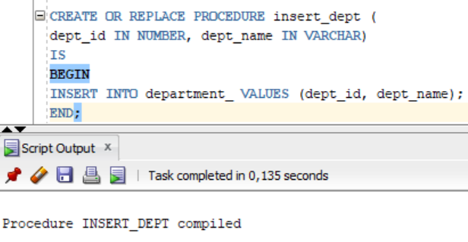

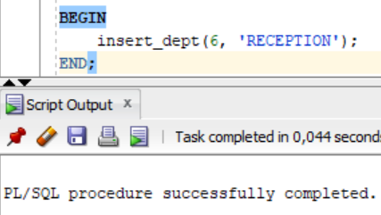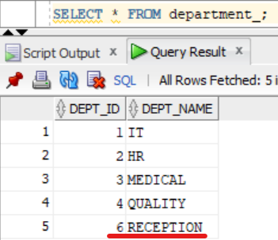

6:08